Class X
Mathematics
Introduction to Trigonometry - Module 1 / 3
Worksheet
- If sin A = $\frac{3}{4}$ , calculate cos A and tan A.
Solution:
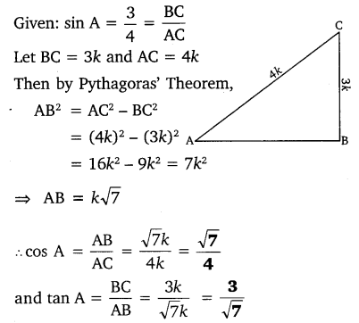
2. In the given figure, find tan P – cot R.
Solution:
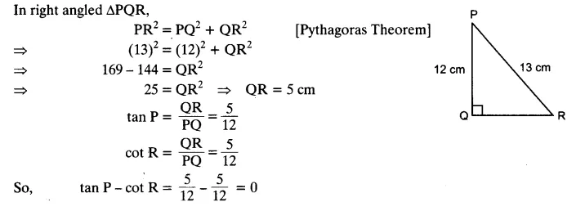
3. Given sec θ = $\frac{13}{12}$ , calculate all other trigonometric ratios.
Solution:
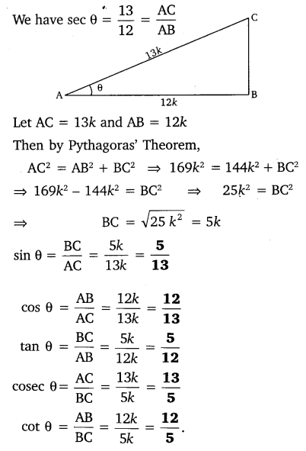
4. Given 15 cot A = 8, find sin A and sec A.
Solution:
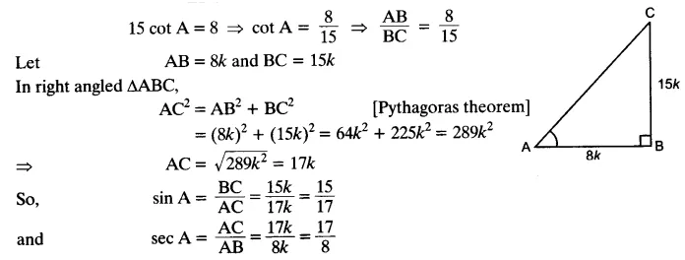
Solve the following

1. In a △ ABC, right angled at B, AB = 24 cm , BC = 7 cm. Determine
(i) sin A , cos A (ii) sin C, cos C
2. In fig., find tan P and cot R. Is tan P = cot R?

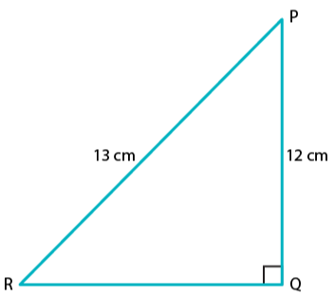

3.In △PQR, right-angled at Q, PQ = 4cm and RQ = 3 cm. Find the value of
sin P, sin R, sec P and sec R.
4. Given 15cot A= 8, find sin A and sec A.
5. If cos θ = 12/13, show that sin θ(1 – tan θ) = 35/156
6. If 3 cot θ = 2, find the value of
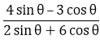
7. If tan θ = a/b, find the value of (cos θ + sin θ)/ (cos θ – sin θ)
8. If tan θ = 12/13, find the value of
